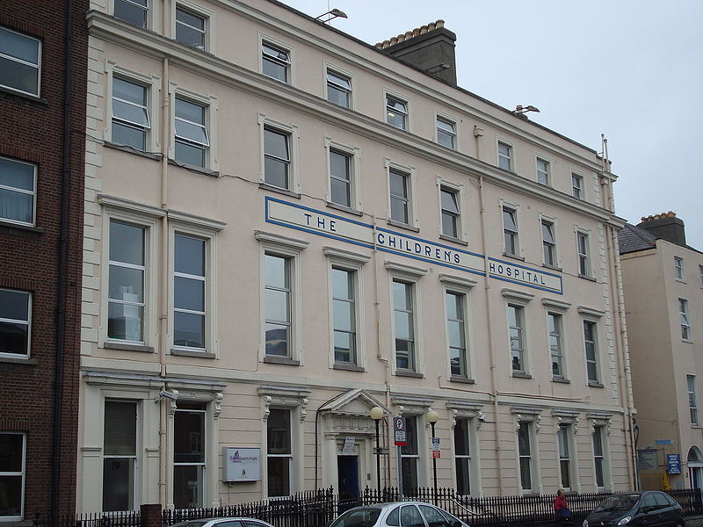

This is Temple Street Hospital.

You are going to come and visit us here soon

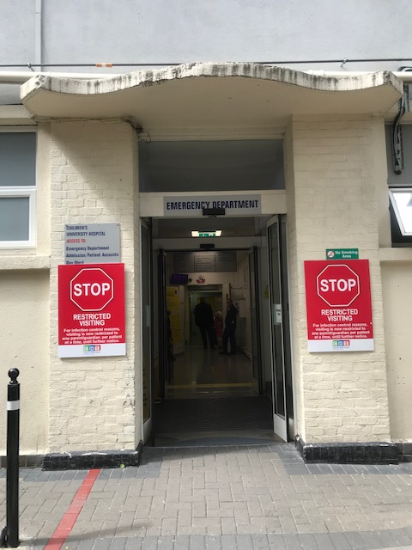

**This is the A&E door where you will come in to the hospital**

**before you come and meet us on the St Gabriel’s Ward**

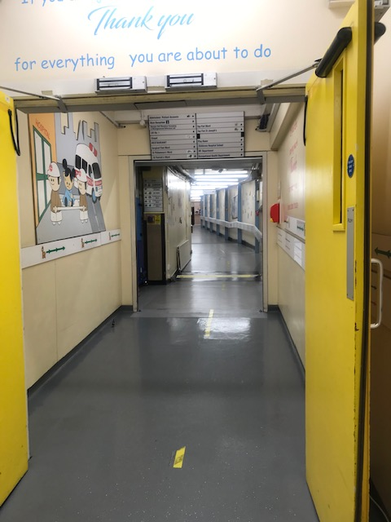

This is our really long corridor that will bring you to the lift

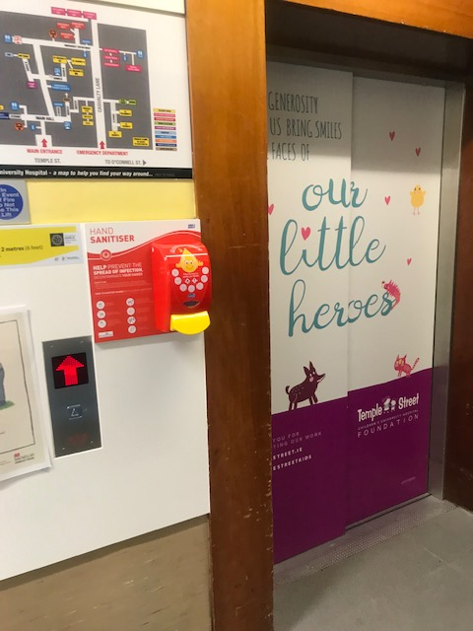

This is the lift you will go in to bring you to floor number 2 where St. Gabriel’s Ward is.

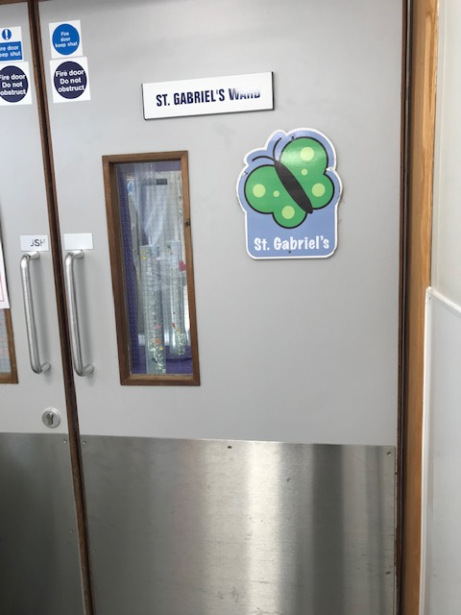

Welcome to St. Gabriel’s Ward !

Through the little window you will see our bubble tube

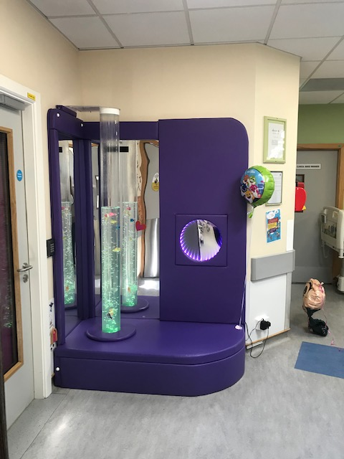

**This is our bubble tube on the ward you can sit here sometimes with your mam or dad if you like and watch the fish swim up and down in the bubbles. We also have a doll house and a kitchen to play with on the ward.**

**We have a playroom in the hospital that you can visit and borrow times from to play with at your bed if you would like to.**

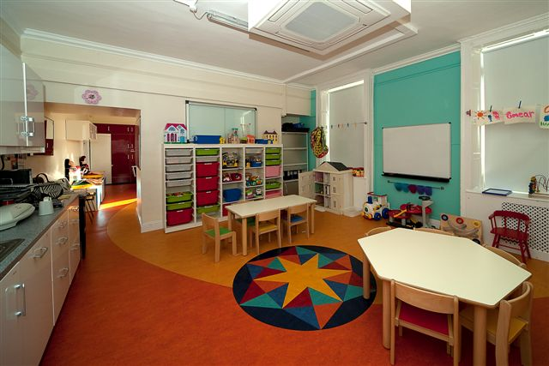

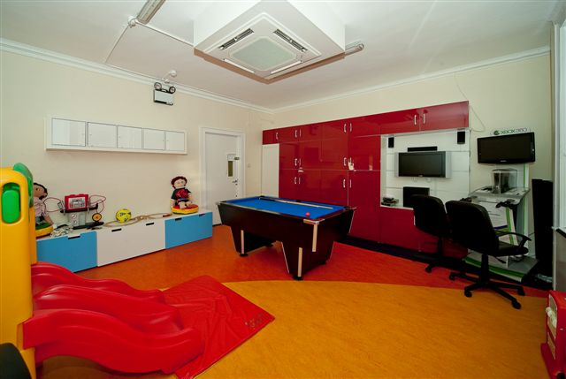

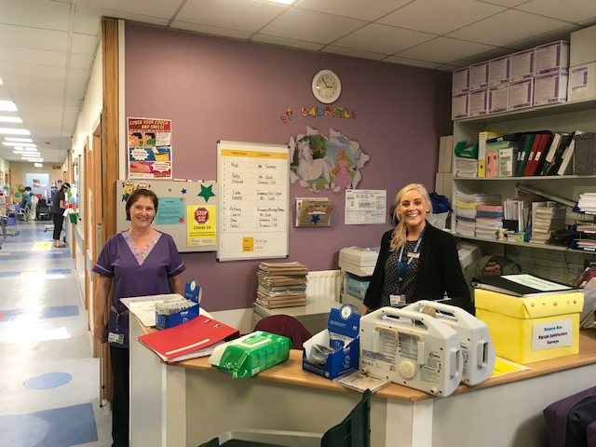

This is Marian and Dolores you will meet them on the ward. They are at Marian’s desk beside the bubble tube.

Can you spot the unicorn on the wall?

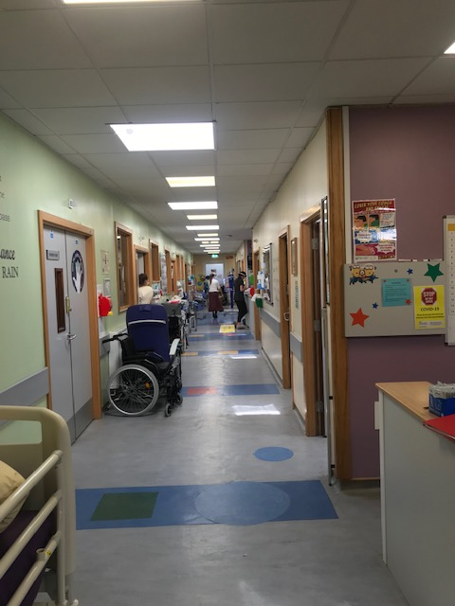

Our ward is really long because we have lots of beds for children to stay in when they need to come stay with us in St. Gabriel’s ward. We have 14 beds on the ward, I wonder which bed will be yours !

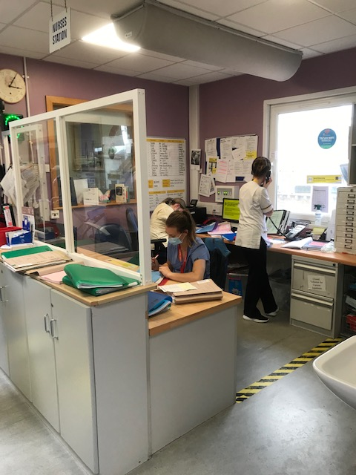

This is the nurses’ station where the nurses sit sometimes to do their work. You will come to the nurse’s station when you come to stay with us and one of the nurses will show you where your bed is.

We look forward to meeting you on the ward.