

Paediatric Neurosurgery Outreach Education Programme

7th February 2025, 0800-1600

Venue-St Georges Hall, CHI at Temple St

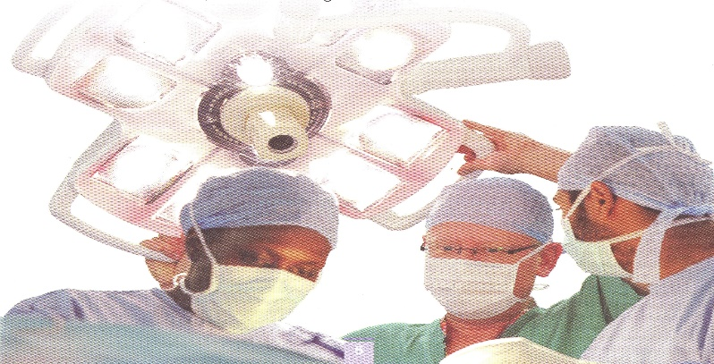

There is no cost to attend this programme & refreshments will be provided

Suitable for all CHI Healthcare Professionals

**Speakers**: Paediatric Neurosurgical Team, Children’s Health Ireland at Temple St & Beaumont Hospital

Topics include:

**Overview of the Paediatric Neurosurgery Service, Paediatric Neurological Observations, Tumours of the Central Nervous System, Hydrocephalus, Closed Spinal Dysphraism, and Developments in Neurosurgery**

**Workshops:** Paediatric Glasgow Coma Score, Head Circumference Monitoring and Surgical Devices

**Poster Presentations**

6 NMBI CEU & RCSI 6 CPD points

Please enrol vis HSELand- go to courses-ONMSD -CNME- enrol on programme.

Enquiries on enrolment please email emma.holohan@childrenshealthireland.ie